Fast**BNational University of Computer & Emerging Sciences, Karachi  
Spring-2022 CS-Department  
Quiz # 3   
23rd May, 2022**

|  |  |
| --- | --- |
| **Course Code: CS3005** | **Course Name: Theory of Automata** |
| **Instructor Name: Mr. Musawar Ali** | |
| **Student Roll No:** | |

**Instructions:**

* Return the question paper.
* Attempting of the question in the given order is highly encouraged.
* Read each question completely before answering it. There are **4 questions on 1 page.**
* In case of any ambiguity, you may make assumption. But your assumption should not contradict any statement in the question paper.
* **Show full steps and provide appropriate reasons wherever possible to get full credit.**

**Time: 60 minutes. Max Marks: 80 points**

**Question 1: Ambiguity in CFGs (10) Points**

Check for ambiguity in the given CFG for the string “**aaabbdd**”.

S🡪 AB|CD

A🡪aAb|

B🡪dB|

C🡪aC $|λ$

D🡪bDd $|λ$

Not ambigious

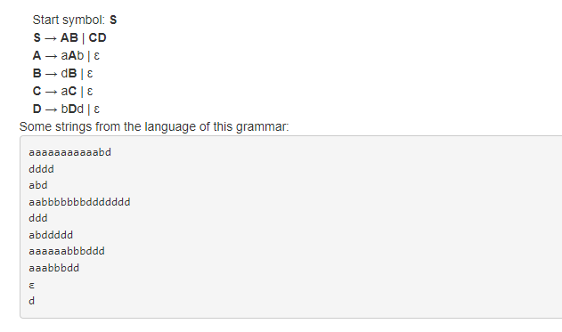

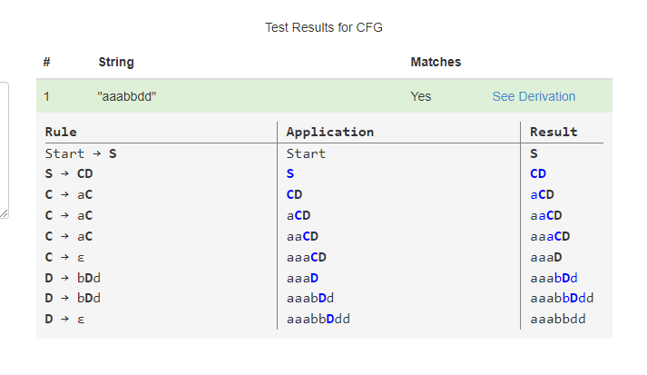

**Question 2: Simplification and CNF (10+10) Points**

Simplify the following CFG and convert it into CNF.

S🡪XY|MN

X🡪0X1|01

Y🡪2Y|2

M🡪0M|0

N🡪1N2|12

The CFG is simplified already.

Converting to CNF

**Put A🡪0, B🡪1, C🡪2,**

S🡪XY|MN

X🡪AXB|AB

Y🡪CY|2

M🡪AM|A

N🡪BNC|BC

A🡪0

B🡪1

C🡪2

**Now put D🡪AX, E🡪BN**

S🡪XY|MN

X🡪DB|AB

Y🡪CY|2

M🡪EC|BC

A🡪0

B🡪1

C🡪2

D🡪AX

E🡪BN

**Note:** show the steps clearly in rectangle boxes, put your simplified CFG and final CFG, converted into CNF in rectangle boxes to get full credit.

**Question 3: PDA (10+10) Points**

Draw the PDA for following languages.

$$L1=\left\{b^{n}a^{m}b^{2n}\right| n≥3,m≥0\} defined over alphabet Σ=\{a,b\}$$

$$L2=\left\{a^{n}b^{m}c^{n}\right|m≥n \& n,m≥0\} defined over alphabet Σ=\{a,b\}$$

**Question 4: CFG to PDA (10+10 + 10 Points)**

Convert following CFG into PDA. Give the instantaneous description of PDA. Trace the string ‘**abaab**’ on the stack and show the steps clearly to get full credit.

S🡪ASA|aB

A🡪B|S

B🡪b|

***For stack you can use these below, rest of solution is attached in pdf.***

***Instantaneous description***

|  |  |
| --- | --- |
| $$\left(q0,λ,\$\right)$$ | ***(q1,s)*** |
| $$(q1,λ, S)$$ | ***{(q1, ASA), (q1,aB)}*** |
| $$\left(q1, λ, A\right)$$ | ***{(q1, B),(q1, S)}*** |
| $$\left(q1, λ,B\right)$$ | ***{(q1, b),(q1, lambda)}*** |
| $$\left(q1, a,a\right)$$ | ***(q1,lambda)*** |
| $$\left(q1, b, b\right)$$ | ***(q1, lambda)*** |
| $$\left(q1, λ,λ \right)$$ | ***(q2, lambda).*** |

